Title: The fitness value of ecological information in a variable world
Running title: The fitness value of information
Authors: Jacob Usinowicz^{1,2} and Mary I. O’Connor^{1,2}

Affiliations:
1. Department of Zoology, University of British Columbia, Vancouver, Canada
email: usinowic@zoology.ubc.ca
2. Biodiversity Research Centre, University of British Columbia, Vancouver, Canada
email: oconnor@zoology.ubca.ca

Keywords: ecology, information theory, population, fitness, community dynamics, coexistence.

Article Type: Synthesis

Author contributions: JU and MIO conceived of the study. JU conducted initial review and development of theory. JU created and analyzed models, and created figures with input from MIO. JU wrote the original draft of the manuscript, JU and MIO wrote and edited subsequent drafts.

Data accessibility statement: All supporting code and data will be publicly archived upon manuscript acceptance and a DOI included in the article. All code and data currently at https://github.com/jusinowicz/fvoi.git

This document file includes:
Abstract: 125 words
Main Text: 7460 words (with references)
Box 1: 642 words
Box 2: 460 words
References: 136
Figures: 5
Supporting Information document

Corresponding author:
Jacob Usinowicz
Department of Zoology
4200-6270 University Boulevard
Vancouver, BC V6T 1Z4
Abstract
Information processing is increasingly recognized as a fundamental component of life in variable environments, including the evolved use of environmental cues, biomolecular networks, and social learning. Despite this, ecology lacks a quantitative framework for understanding how population, community, and ecosystem dynamics depend on information processing. Here, we review the rationale and evidence for ‘fitness value of information’ (FVOI), and synthesize theoretical work in ecology, information theory and probability behind this general mathematical framework. The FVOI quantifies how species’ per-capita population growth rates can depend on the use of information in their environment. FVOI is a breakthrough approach to linking information processing and ecological and evolutionary outcomes in a changing environment, addressing longstanding questions about how information mediates effects of environmental change and species interactions.

Quantifying information in ecology
Biology is built upon information.From genetic architecture (Smith 1999; Goldenfeld & Woese 2007; Tkačik & Bialek 2016), to sub-cellular biomolecular networks (Tyson et al. 2002 ; Woods & Wilson 2013; Cai et al. 2018), to the countless examples of derived sensory apparatus in organisms, life is replete with mechanisms for detecting, processing, and storing information (Dangles et al. 2009). Natural selection itself is an information process, where changing gene frequencies encode population-level information about the fitness consequences of the environment (Smith 1999; Frank 2012). Ecological studies account for myriad ways that organisms across all kingdoms of life respond to changing environments and use cues in their environment to find resources, refuges, and reproduce (Crespi 2001; Crone et al. 2009; Gil et al. 2018). However, accounting for the explicit role that information plays in population, community, and ecosystem dynamics remains a largely unexplored research frontier (O’Connor et al. 2019; Marleau et al. 2020).
Information is increasingly acknowledged as a universal and essential component to life in fluctuating environments (Berhardt et al. 2020). Historically, information has been equated with a variety of environmental cues. These include environmental changes that trigger phenological shifts (Cohen 1966; Ellner 1997; Clauss & Venable 2000; Thackeray et al. 2016; Ten Brink et al. 2020), social or chemical signals used to find food (Danchin et al. 2004; Magrath et al. 2015; Gil et al. 2018), shared between bacteria to monitor local densities (Crespi 2001), or transmitted between plants as volatile organic compounds triggered by defense against herbivor (De Moraes et al. 1998; Baldwin et al. 2006). While these important studies have guided scientific progress, taken collectively they create an idiosyncratic, system-specific perspective on information the precludes generalization. Furthermore, they tend to lack a dynamical framing of information’s role.
A generalizable definition of information that captures the functional role of biological cues can be found in information theory (Goldenfeld & Woese 2007; Tkačik & Bialek 2016). In information theory, information is measured in relation to the uncertainty or “surprisal” of an event. Observing a less-probable (more surprising) event is more valuable precisely because there are fewer opportunities to do so and an observer will be better-informed after a rare event than it is after a common event. For example, in a generic desert environment temperatures are typically hot and rain is infrequent. The chance of experiencing rain on any particular day is very low, so it is unsurprising to learn that rain is absent on any day; low surprise indicates that little information has been gained by noting its absence. By comparison, learning that it has rained conveys more information because of its novelty. Formally, surprisal is quantified as the log (1 / probability (event)) and this standardized unit of information forms the basis for information theoretic metrics including the Shannon Entropy. This concept of information as related to surprise extends joint probabilities of two (or more) events and leads to metrics of shared information such as the mutual information (MI). For example, temperature patterns often contain information about rain and the information about rain carried by temperature can be quantified by the MI.
Information theory revolutionized our thinking by demonstrating that information itself is measureable on a universal scale that is inherently free of value or meaning (Frank 2012). Ecologists, however, often explore the biological value derived from information without understanding the information itself. What is necessary then are frameworks that link information with biological value and clarify how much ecological dynamics are driven by information per se versus its biological utility (Frank 2012). The mathematical framework for the fitness value of information (FVOI) (Donaldson-Matasci et al. 2010; Rivoire & Leibler 2011) is a key innovation developed to bridge information theory with biological concepts of species’ fitness. The core insight of this theory is that the biological value of information can be measured via its effects on a population’s fitness. Ecology and evolution share a universal measure of population-level fitness measured in terms of per-capita population growth rates. The FVOI quantifies how information changes a population’s fitness in varying environments by measuring changes in per-capita population growth rates; if information improves an organism’s ability to consume resources, locate mates, or survive then per-capita growth rates increase relative to when information is absent (Gould 1974; Stephens 1989; Donaldson-Matasci et al. 2010; Rivoire & Leibler 2011)(Figure 1). A focus on per-capita growth rates links FVOI with other approaches for analyzing stochastic population growth in ecology including classic models of bet-hedging in annual plants (Gillespie 1974; Philippi & Seger 1989) and copepods (Hairston & Dillon 1990), and coexistence theory (Turelli 1978; Chesson & Warner 1981). By explicitly parsing the information content of per-capita growth rates, the FVOI builds on this work and offers novel insight into the dynamics of populations in fluctuating environments (Stephens 1989; Donaldson-Matasci et al. 2010; Rivoire & Leibler 2011).
A major advantage of the FVOI framework is that it simplifies the accounting of costs and benefits of using information by shifting focus from the organismal to the population level. Information use can only increase fitness if the energetic gains outweigh the costs associated with detecting and using information. Organisms bear metabolic costs to implementing and maintaining sensory machinery (Koch 2004; Keller & Surette 2006; Nelson & MacIver 2006; Barth & Schmid 2013; Gil et al. 2018) and cellular or biochemical networks for information (Laughlin et al. 1998; Bruce et al. 2007; Bullmore & Sporns 2012; Crisp et al. 2016), even when organisms may take advantage of already existing biochemical pathways (Baldwin et al. 2006). But information can have numerous emergent benefits, as when matching the phenology of flowering to favorable growth conditions compounds benefits through pollination success (Strauss 1997), herbivory avoidance (Schauber et al. 2002), or a reduction in interspecific competition (Usinowicz et al. 2012). The FVOI encompasses these costs and benefits to using information because quantifying the overall net impact of these processes is subsumed in rates of population change.
The goal of this paper is to develop the FVOI as a general framework that guides ecological intuition about information’s role in ecological dynamics; it is not our objective to review information theory (Goldenfeld & Woese 2007; Tkačik & Bialek 2016) and we only define specific concepts as they become relevant to understanding the FVOI. We present an intuitive heuristic derivation of FVOI for general ecological audiences (Measuring the fitness value of information), review the mathematical framework first presented by Donaldson-Matasci et al. (2010) (Box 1), and describe how FVOI can be measured in theory and empirically. We briefly review the historical development of information-based population models in ecology in order to illustrate core principles of FVOI, point out where the theory can inform empirical applications, and demonstrate a novel extension to competitive communities (Parsing information’s contributions to fitness). Finally, we review studies where organisms make fitness-related decisions (behavioral and developmental) in response to environmental cues (biotic and abiotic) (Biological examples of information’s value). Beyond reviewing the literature, we highlight the potential for FVOI to facilitate novel, testable ecological hypotheses in particular systems (Marleau et al. 2020), and help unify our understanding of anthropogenic impacts on the information content of environmental cues (McMahon et al. 2017; Barton et al. 2018). A major strength of the FVOI is that it can link disparate bodies of work through fundamental principles; in a variable and uncertain world organisms constantly face decisions (or, developmental junctures) with population-level consequences on the long-term persistence of their species, and average fitness outcomes improve when populations of organisms make informed decisions.

Measuring the fitness value of information
Evidence that information has fitness value seems unequivocal when considering the countless adaptations found in species to detect, process, and produce cues. An integrated measure of the fitness value of information can be made by measuring population growth rates with the benefits, costs, and community context embedded in population dynamics (Cover & Thomas 2006; Donaldson-Matasci et al. 2010; Rivoire & Leibler 2011). Here we present a heuristic derivation of the FVOI for ecology that synthesizes studies which have derived this relationship from fundamental mathematical, information-theoretic principles to understand evolutionary dynamics (Box 1) (Donaldson-Matasci et al. 2010; Rivoire & Leibler 2011).
Fitness can be given a concrete, mathematical, definition. Ecologists (Turelli 1978; Chesson 1994; Ellner et al. 2016) and evolutionary biologists (Haldane & Jayakar 1963; Cohen 1966; Ellner 1987) measure fitness using per-capita population growth rates: fitness is the expected value (average) of the logarithm of per-capita population growth rates (Frank 2016). Ecologists commonly model population growth with discrete-time models:

. (1)

Here, λ_{i}(t) is the per-capita growth rate of population i, which is typically a function of demographic parameters including survival and fecundity (Box 2). This indexing may refer to a species, a phenotype, or a strategy depending on the study context; what is consistent is that all individuals within population i have an identical response. A population’s expected long-term growth rate 𝜌_{i} is the geometric mean of the per-capita growth rate:

(2)

The E[ ] signifies the expectation over many realizations and is defined for both discrete- and continuous-time models. The continuous-time analogue is and G_{i}(t) = 𝜌_{i} is the log-growth rate.
In theory, 𝜌_{i} can be calculated for any specification of λ_{i}(t). By measuring 𝜌_{i} under different models or parameterizations of λ_{i}(t), biologists have used it to compare how different processes or environmental conditions impact fitness. For example, the theory of coexistence in fluctuating environments (Turelli 1978; Chesson 1994) is effectively based on a comparison of two versions of 𝜌_{i},one with and one without a varying environment; their difference measures how much per-capita growth rates depend on environmental variation (Usinowicz 2015; Shoemaker & Melbourne 2016; Barabás et al. 2018). In evolutionary theory, 𝜌_{i} provides a measure of the fittest strategy or adaptation when compared across different phenotypes in a population (Cohen 1966; Ellner 1997).
The FVOI framework is based on comparing 𝜌_{i} under different assumptions of information availability, usage, and cost. This assumes that λ_{i}(t) can be calculated with and without information components. Stated pseudo-mathematically (see Box 1 for full mathematical derivation), the fitness value of information is measured as the difference between 𝜌_{i} (informed) and 𝜌_{i} (uninformed):

(3)

Applying Δ𝜌_{i} to simple models of population growth shows that two key information-based mechanisms (sensu ‘coexistence mechanism’) contribute to fitness (Donaldson-Matasci et al. 2010; Rivoire & Leibler 2011). The first mechanism defines the maximum fitness benefit that could be obtained by perfectly detecting and utilizing a cue. It is equivalent to the information-theoretic correlation between environmental variation and the potential cue (another varying signal related to the environment), known as the mutual information (MI) (Figure 1). The MI measures how much information the cue conveys about the availability of a good (or bad) environments and it is proportionate to the maximum fitness value obtainable through the cue (Donaldson-Matasci et al. 2010; Rivoire & Leibler 2011). The MI is positive, and zero when the cue and the environment are independent.
The second information mechanism in the FVOI estimates the fitness consequences of failing to utilize the available information in the MI. This mechanism is defined by the Kullback-Leibler (KL) divergence (D_{KL}), which is a statistical distance (not a true distance metric) between two probability distributions; biologically, it measures how much the population’s distribution of responses to the environment differs from the actual distribution of environments (Box 1; Figure 1C,D)). If detection of and response to the environment perfectly anticipate patterns of environmental variation then the KL divergence is zero and the population makes full use of the MI between cue and environment.
The MI between a cue and future environmental conditions defines an upper limit for how much a source of information can improve fitness (Donaldson-Matasci et al. 2010; Rivoire & Leibler 2011). This result confirms intuition that uninformative cues should not be expected to contribute to fitness. Furthermore, the significance of MI as a bound on fitness benefit provides justification for using MI as a simple metric to identify cues with potential fitness value.

Parsing information’s contributions to fitness
In practice, Δ𝜌_{i} can be used to quantify the fitness value of information whenever per-capita population growth rates in fluctuating environments can be measured. Many studies of persistence and coexistence in fluctuating environments have measured 𝜌_{i}(informed) through experiments(Grainger et al. 2019), parameterization of mathematical models with observational data (Adler et al. 2006; Usinowicz et al. 2017), or other approaches. However, measuring 𝜌_{i}(uninformed) may require novel approaches that can remove sources of information, alter populations’ access to information, or remove correlations between cues and populations’ responses to them. The analytical parsing of the FVOI into information mechanisms (Box 1; Donaldson-Matasci et al. 2010; Rivoire & Leibler 2011) opens multiple options to accommodate a variety of ecological data. In particular, it reveals that measuring 𝜌_{i}(informed) in conjunction with the environment and potential cues should generally be sufficient to quantify Δ𝜌_{i} via its information components the MI and KL divergence.
In this section, we review the literature that has explored FVOI in single-species models and highlight the data that could be used to estimate FVOI in these contexts. We review a classic motivating system in ecology (dormancy and germination in annual plants) where the idea of informed resource allocation links ecology to probability theory’s concept of betting. Even the simplest mathematical models which link ecology and betting scenarios have provided tremendous insight into natural dynamics, but much still stands to be gained by extending analysis to models which include processes like dormancy, density dependence, and interspecific competition. Details of simulations presented in this section can be found in the Supporting Information.Code and data files are available at https://github.com/jusinowicz/fvoi.git .

Betting on success: timing of seed germination in annual plants
A classic motivating example for the FVOI is understanding how annual plants time germination in fluctuating environments. Each generation, reproductive fitness is determined by a different (but bounded) set of environmental conditions. Dormant seeds within the population can germinate or remain dormant. If they germinate, short-lived adults produce new seeds at rates determined by the favorability of environmental conditions.
Annual plant population dynamics have been represented mathematically by models of betting (Cohen 1966; Ellner 1997), and extended to include community interactions between zooplankton (Cáceres 1997), fish (Chesson & Warner 1981; Secor 2007), trees (Usinowicz et al. 2017), and viruses (Stumpf et al. 2002). A population is treated as a bettor with capital (seeds) to gamble on event outcomes (environmental conditions) with predetermined payouts (reproductive fitness).The role of the bettor is to decide when and how much to gamble on each event (the conditions each year). The simplest betting models assume that a bettor gambles all capital on every event and the challenge is to allocate bets across a portfolio of possible outcomes (Box 1). Other models allow a bettor to store capital when poor payouts make any gamble disadvantageous (Box 2). Although biologically simplistic, the betting analogy provides intuition about the value of information; a bettor can increase earnings when more knowledge about event outcomes means that larger bets can be made with certainty. Biological studies have used betting-with-storage models to quantify population-level consequence of observed germination and reproduction patterns, but have not parsed the role of information itself in per-capita growth.
Linking the betting analogy and population dynamics in fluctuating environments necessitates certain assumptions. The ecological equivalent of an ‘event’ is a multivariate space of environmental conditions E (Box 1) that are biologically relevant, e.g., moisture, temperature, and nutrient availability. An ‘event outcome,’ denoted e (Box 1), is a realized combination of these conditions, represented as a point in multivariate environmental space. It is common (but not necessary) to model discrete events because gambling has discrete outcomes; a particular number is drawn, or a particular horse wins a race. Analogously, ecological data is often made as discrete observations and binned into discrete, non-parametric distributions, but all approaches discussed here have continuous analogues for continuous data and distributions.
The betting problems that motivate theory imbue bettors with decision-making abilities. Bettors have internal models of probabilities that they use to make decisions (x_{i,}(e) in Box 1). In reality, the internal model is just a device to illustrate a mathematical concept and should not be taken too literally; the internal model is the distribution of x_{i,}(e) dictating the proportion of resources bet on an outcome(e.g. Box 1). Extending the analogy of internal models to populations leads to interesting biological questions. Populations may improve decisions as individuals learn about probabilities, just like a bettor may learn. In other cases, “decisions” are hard-wired life history transitions initiated by the right stimulus. For example, the “decision” of a seed to germinate is not behavioral, it is driven by biochemical reactions initiated within the seed coat that generate a cascade of developmental changes. The “internal model” is the population-level manifestation of these decisions because the allocation of resources to reproduction is a population-level phenomenon. Thus the analogy to probability theory means that the population is the bettor whose internal model is the distribution across all individual-level decisions. Then, 𝜌_{i} is the per-capita rate at which a bettor accumulates wealth or a population accumulates new individuals.
A naive bettor (population) is uninformed about the distribution of possible outcomes. An uninformed internal model may take various forms and a common choice is to assume all outcomes are equally likely, or uniformly distributed. This uninformed baseline appears in Bayesian statistics (uninformed priors) and it is the maximum entropy (maxent) distribution in information theory (Cover & Thomas 2006). In the FVOI, maximum entropy establishes a baseline of per-capita growth rates because it is the best a population can do with no information about future environmental states. Other distributions might be more biologically appropriate in other contexts and the framework works regardless of this choice. Furthermore, we do not expect uniformity to occur in real populations and emphasize that this is a mathematical device which simplifies and standardizes analyses. The uninformed per-capita growth rate is formally denoted as 𝜌_{i}(uninformed) = 𝜌_{i} ( x_{i} (E ~ U(0,1) ) ) = 𝜌_{i} (E~U), where x_{i} (E) is the proportion that a population gambles on each environmental state (its internal model), U(0,1) is the uniform distribution on the interval 0 to 1, and 𝜌_{i} (E~U) is a shorthand (Box 1).
Often, a population (bettor) may have an approximation of the likelihood of possible states (outcomes) from past states, written formally as 𝜌_{i} ( x_{i} (E) ) = 𝜌_{i} (E) to indicate that some internal model of probabilities motivates allocation of resources (bets). For example, a bettor might know how often horses in a race have won in the past and this informs their likelihood of winning now. In a population, individuals may have learned through past observations (Aplin et al. 2015; Gil et al. 2018),or phenotypic distributions may have evolved that reflect the frequency of historical environmental patterns (Kussell & Leibler 2005; Donaldson-Matasci et al. 2008; Frank 2012).
To illustrate, consider how the simplest betting or population dynamics are captured with a simple model like eq. 1 with N_{i}(t) as wealth (bettor) or individuals (population), and λ_{i}(t)=R_{i,e} x_{i}(e), where x_{i}(e) is the proportion of individuals (wealth) invested in a particular environment or event outcome e and R_{i,e} is the payout for that outcome. This equations says that all individuals (wealth) are invested every time-step, so every x_{i}(e) that does not match e is a loss to the population (bettor). Thus it is important to have a distribution (portfolio) of investments across all e, where the full distribution of x_{i}(e) then represents the internal model of the bettor or population. The optimal allocation strategy for this simple process under this minimal or marginal information scenario (i.e., knowing only the marginal distributions of events based on historical outcomes) is to divide x_{i}(e) among e in proportion to their probability of occurring. This is referred to as the Kelly criterion or Kelly betting (Cover & Thomas 2006), and was derived to explain the optimal strategy by which a bettor maximizes winnings across many horse races (Kelly 1956; Cover & Thomas 2006). Kelly betting is robust because it is independent of underlying mechanisms (cognitive or evolutionary) (Box 1). In the development of the FVOI, the Kelly criterion is used by Donaldson-Matsci (2010) as an uninformed baseline. See Figure 2A for a comparison of the uninformed and marginally informed models, and the SI for model details.
Importantly, the Kelly criterion covers a scenario of historical information accumulation that only allows a bettor (population) to make an educated guess about future outcomes based on past events. If organisms can detect information that predicts future events, then more effective strategies exist. For example, annual plants germinating in arid environments where reproductive success is limited by moisture availability can respond more effectively if populations can use environmental cues to anticipate future precipitation. Formally, some factor such as the amount of moisture today is a cue C (where each realization is c, e.g. Box 1)if it is predictive of future precipitation and there is high MI between C and the states E of rain. The MI is calculated using the conditional probabilities of seeing an amount of rain in the future given current moisture levels p_{i} (E|C). The probability p_{i} (E|C) ranges between 0 and 1, 0 indicates total independence of these two events, and 1 indicates that the current cue is perfectly predictive. The distribution p_{i} (E|C) can be interpreted as a statement on the reliability of a cue, where a value close to 1 means that a certain cue is almost perfectly predictive of an outcome. The corresponding per-capita growth rate is 𝜌_{i} ( x_{i} (E|C) ) = 𝜌_{i} (E|C).
The additional fitness gain when information is available (e.g., MI > 0) can be substantial (Figure 2A, 2C; Box 1; Donaldson-Matasci et al. 2010). Now, a population (bettor) will maximize its gains by allocating according to p_{i} (E|C): when p_{i} (E|C) approaches1 it becomes increasingly advantageous for a population (bettor) to gamble all of its resources on the corresponding outcome. This is captured formally through an extension of the Kelly criterion for p_{i} (E|C) (Cover & Thomas 2006). As long as the information is reliable (i.e., the conditional probability distribution has less variation than the uninformed marginal distribution) then populations can better allocate resources and Δ𝜌_{i} will increase. For example, in Figure 2A, where the simplest growth (betting) model has been plotted over time, the per-capita growth rate of a population that uses information is greater than the uninformed populationThe difference between these growth rates (i.e. the difference in slopes) is the FVOI (Δ𝜌_{i} ) (Figure 2C). Note from Figure 2C that the FVOI and MI are equivalent, showing that populations have fully utilized the information in the cue and maximized the FVOI.
In reality, populations rarely invest all of their resources into per-capita growth and instead store resources across reproductive events. This strategy, known as bet-hedging (Gillespie 1974; Philippi & Seger 1989), is ubiquitous (Clauss & Venable 2000; Stephens et al. 2002; Childs et al. 2010; Tielbörger et al. 2012; Furness et al. 2015). It is evident wherever there is some form of “storage”, whether through long-lived adults found in perennial plants (Adler et al. 2006; Usinowicz et al. 2012) and fish (Secor 2007), or propagules including seeds (Sears & Chesson 2007; Jose M. Facelli et al. 2008) and eggs (Cáceres 1997) that can remain dormant for long periods. See Box 2 for model details. Bet-hedging is optimal when odds are “subfair,” i.e. when the sum over the reciprocal of the payouts (odds) of each event is greater than 1 ( sum(1/odds) >1 )(relative to fair = 1, subfair < 1; see e.g. Cover & Thomas 2006, Ellner 1997 ). Basic organismal physiology tends to constrain organisms such that there will be some conditions under which reproduction rates approach 0, likewise making the odds of reproductive success 0. Brief consideration of the equation for subfair odds above leads to the observation that we should probably never expect nature to be fair; even one outcome with odds approaching zero will lead to very large or even infinite sums. Because nature is not fair, bet-hedging should be the norm.
Information improves fitness for bet-hedging populations in variable environments (Box 1: Donaldson-Matasci et al. 2010). As with model 1 (Figure 2A), the per-capita growth rate for bet-hedging populations is higher when individuals use cues to time reproduction to align with favorable conditions (Figure 2B; see SI for simulation details). Per-capita growth in a bet-hedging population is lower because dormancy introduces constraints on the FVOI. Dormancy represents increased phenotype specialization when individuals of a certain phenotype are increasingly specialized to emerge in response to specific cues. This physiological trade-off between generality and specialization can prevent a population from fully exploiting the information in a cue (see Box 2). The fitness cost of a physiological constraint like dormancy can be measured by parsing the FVOI, done numerically in Figure 2C-D. In the first scenario, the FVOI is equivalent to the MI (Figure 2C) revealing that the population/organism are able to perfectly use the MI in the environment. In the second case, the FVOI measured by the difference in slopes is no longer equivalent to the MI (Figure 2D). Note that this difference between Δ𝜌 _{i} and MI is the KL divergence, which measures the information a population fails to use.
The theory reviewed here creates a general foundation to unite phenomena from phenology, to behavior, to intraspecific diversity. Some predictions and assumptions remain to be tested. For example, in the context of these dynamics almost any information use has the potential to increases a population’s fitness, and certainly the use of cues to anticipate environmental conditions is ubiquitous in real organisms. Likewise, the mathematical conditions that make information advantageous (i.e., variable environments with sub-fair odds) are probably the rule. A primary point of contention in annual plant systems, where bet-hedging has been well-studied, is whether conditions that make a cue informative actually exist (Venable & Lawlor 1980; Clauss & Venable 2000). To our knowledge, no attempts have been made to measure the MI between environmental conditions which benefit reproduction and seed germination cues. This may not be surprising, however, since demography and phenology have perhaps not been considered in the context of a formal information-based framework before. It also remains unknown how often and to what extent biological constraints (including dormancy) might reduce the FVOI such that there is no net fitness value. Finally, the insights garnered here are based on theory developed for single-species populations without conspecific interactions (e.g. intraspecific competition). The few studies that consider fitness value in social information point to a complex landscape of fitness tradeoffs that depend on several factors, but tend to support the potential for information to improves fitness in general (Gil et al. 2017, Gil et al. 2019, Hein and Martin 2020).

Information’s contributions to fitness in communities and community dynamics
Given information’s potential to influence population dynamics in scenarios that consider only the population and its environment, we expect that information use and the fitness advantages it confers may be an important dimension of fitness in communities. Single-species models only capture a direct influence of information on fitness (Donaldson-Matasci et al. 2010; Rivoire & Leibler 2011), and do not account for the density- and frequency-dependent feedbacks that drive biodiversity (Adler et al. 2007; Hart et al. 2017; Usinowicz et al. 2017; Letten et al. 2018). Probability theory has not probed such models with feedback dynamics that would be informative in these more complex ecological contexts. Several studies explore the fitness value of social information in multispecies communities, but their relationship to the body of theory behind the FVOI remains unresolved (Gil et al. 2017, Gil et al. 2019, Hein and Martin 2020).

How do species interactions mediate the fitness value of information?
Here we extend two classic ecological models of population dynamics in fluctuating environments by adding the potential for information-driven dynamics (Box 2). The first of these is a novel extension of the lottery model (Chesson & Warner 1981). Species compete based on the proportion of offspring that emerge each generation (e.g., germinating proportions of seeds). We introduce the potential for emergence to use information in the form of a cue that predicts favorability of environmental conditions; biologically, this might mean high MI between early and later season factors such as precipitation, or a more general set of conditions. Mathematically, the proportion of emerging individuals is based on the conditional probability of seeing a favorable environment given a cue p(E|C). As such, the lottery model with information is an extension of the single-species models used in Donaldson-Matsci et al (2010), and an extension of the lineage of bet-hedging models (Ellner 1997; Hairston et al. 1995) with competition added. An overview of this model for two species is given in Box 2, and the different competitive dynamics when germination is conditioned on a cue or not, are given in Figure 3.
Information use benefits species that are competing for a shared, fluctuating resource, evidenced by comparing population growth rates for informed and uninformed populations (Figure 3). At a particular level of overlapping interspecific resource use (i.e., niche overlap), the ability to use information about temporal patterns in the environment has clear and quantifiable fitness benefits. It follows to ask, does the FVOI depend on the niche overlap of competitors? To answer this question, we simulated the model across different levels of resource use overlap (keeping species’ average reproduction rates equivalent to one another) and applied Δ𝜌_{i} to measure changes in the FVOI across scenarios. It is clear from the results in Figure 4A that increasing niche overlap through increases in species’ shared environmental preferences leads to a decrease in FVOI. This means that high interspecific similarity in resource and environmental needs also decreases the opportunity for species to avoid competition through information about patterns of variation in those resources.
We can also ask, how does information influence coexistence? We can address this question by applying Δ𝜌_{i} to the model simulated over the same range of resource overlap scenarios and calculating the niche differences (note that species were given equivalent fitness) from the two different sets of low-density growth rates, 𝜌_{i} (E|C) and 𝜌_{i} (E~U) following previous methods (Carroll et al. 2011; Grainger et al. 2019). The magnitude of niche partitioning with 𝜌_{i} (E~U) at any particular level of resource overlap reveals the potential for resource partitioning alone to promote coexistence, while the difference in niche partitioning between 𝜌_{i} (E|C) and 𝜌_{i} (E~U) reveals the extent of niche differentiation that is purely information based. Information can promote coexistence by further decreasing niche overlap and this effect can be distinguished from purely resource driven niche partitioning (Figure 4B). Information promotes niche partitioning in this model by increasing each species’ ability to target reproductive effort in its preferred resource environments. As a result heterospecific individuals will encounter each other less frequently and conspecific interactions will increase, decreasing interspecific competition relative to intraspecific competion. Since broader niche differences facilitate coexistence and the maintenance of biodiversity, our results show that information can help maintain biodiversity in ecological communities. These results reinforce the few other studies where (social) information was found to have tremendous potential to qualitative change competitive outcomes from exclusion to coexistence (Gil et al. 2017; Gil et al. 2019). However, these studies also highlight a complex, context-dependent suite of possible outcomes for information-driven dynamics, including Allee affects and reversals of coexistence (Gil et al. 2019).

Fitness value of Social Information
Information exists in the environment in the patterns and behaviors of other organisms, in addition to patterns in the environment as we have considered so far (Gil et al 2018). When organisms detect physiological, chemical, or behavioral responses in other individuals these cues are called social information. We also investigated the FVOI in a model of social information based on classic Lotka-Volterra dynamics (Box 2) (Gil et al. 2018). This version of the model includes al density-dependent term where interaction rates determine the value of social information passed between con- and heterospecifics. We illustrate the different dynamics with and without social information in Figure 5. The main takeaway is that information again increases the rate at which a population recovers from low density. It does not impact the equilibrium density; it is likely possible that other model formulations could influence equilibrium density and this remains to be explored. The simplicity of this model makes it straightforward to assess analytically, and serves as a proof-of-concept because applying Δ𝜌_{i} to the model in Box 2 recovers the term B_{i}(N_{i}...N_{n}) included to represent information dynamics. This means that the FVOI is equivalent to the value of social information in this example, and shows more broadly how different types of ecological information can be nested and compared within the FVOI framework.

Biological examples of information’s value
All populations must contend with fluctuating environments, and most temporal patterns of variation contain information that can be used to inform predictions about likely future conditions (Pennekamp et al. 2019). By using information in the environment, organisms stand a better chance of tracking beneficial conditions and avoiding detrimental ones. Information is present in cues when they correspond to patterns of environmental variation, and information is useful when it is predictive of conditions that promote or inhibit species’ growth or reproduction, and when that information is detectable to the organisms. Species have evolved or learned responses to specific cues, which signal behavioral decisions or life history responses. Although the majority of our study has considered environmental cues to this point, cues may also come in the form of social information from con- or heterospecifics that help avoid predation, or improve the likelihood of finding resources or mates. A vast number of studies enumerate examples of this ecological information without explicitly connecting cue responses to population or community dynamics. Here, we discuss how ecological information, in the form of abiotic and biotic cues, mediates fitness via two primary pathways: 1) environmental information, when demographic rates change in response to a unidirectional flow of information from environment to organism and 2) social information, when population densities change in response to exchanges of information between con- or heterospecific individuals.
Environmental information includes cues that trigger shifts in demographic rates, often through life-history changes. These demographic responses are independent of population densities. In our models, demographic responses would be represented by a changing parameter value such as fecundity, germination or survival rate (Box 2). Examples of environmental information with demographic consequences encompass cues for the timing of dormancy and emergence in plants (Thackeray et al. 2016; Montgomery et al. 2020), animals (Koštál et al. 2017; Wilsterman et al. 2021), and bacteria (Jones & Lennon 2010). Plants that experience seasonally harsh conditions often become dormant, and regrowth and germination (Tielbörger et al. 2012; Commander et al. 2017) respond to cues associated with the onset of favorable conditions (Box 2). In some cases environmental information originates from other organisms. Terrestrial and aquatic invertebrates are known to switch between phases of parthenogenesis, with rapidly hatching eggs, and sexual reproduction, with long-lived diapausing eggs. This switch can occur in response to a combination of cues but is often induced by predation (Hairston & Dillon 1990; Hairston Jr & Kearns 1995). Many larval amphibians switch growth, development strategies, and behavior when predators are detected (Relyea 2003).
Environmental information can indirectly influence density- and frequency-dependent population processes (Box 2). The seasonal timing of reproduction in many organisms can produce competition (Chesson & Warner 1981; Usinowicz et al. 2012; Godoy & Levine 2014), predation (Barbraud & Weimerskirch 2003; Tyson & Lutscher 2016), and promote mutualisms (Moeller 2004; Devaux & Lande 2009; Fabina et al. 2010). For example, when the seeds of desert annual plants germinate in response to moisture and photoperiod, there is competition for limited resources (Pake & Venable 1995; Alexander & Levine 2019). This tends to increase intraspecific competition since conspecifics are more likely to respond to similar cues; if intraspecific competition is high on average relative to interspecific competition then population growth rates will be negatively frequency dependent and coexistence is possible. This is the essence of the frequency-dependent mechanism known as the storage effect, which has been documented in numerous organisms in addition to annual plants (Cáceres 1997; Angert et al. 2009; Ellner et al. 2016; Usinowicz et al. 2017).
Social information is based on cues that are passed between organisms as an interaction or feedback. The production of and response to social information are typically linked through density-dependent feedbacks in population dynamics, for example when conspecific attraction increases fitness by increasing reproduction rates (Bever & Simms 2000; Schmidt et al. 2015), resource acquisition (Berryman et al. 1985; Sultan 2000; Williams et al. 2000), or predator avoidance (Costerton et al. 1995; De Moraes et al. 1998; Gil et al. 2019). Positive density-dependent feedbacks emerge when social cues increase in magnitude or value with increasing population density (Box 2). Negative density-dependent feedbacks can result when social information repulses con- or heterospecifics (Durrett & Levin 1997; Chivers & Smith 1998). Spatially explicit feedbacks lead to heterogeneous distributions of populations that can lead to some of the complex phenomena and non-intuitive outcomes that have been studied in the context of coexistence and predator avoidance (Huffaker 1958; Levin 1992; Bolker et al. 2003; Snyder 2006).
Social information is also shared between species. This can produce density-dependent feedbacks driven by interspecific interactions with major implications for community dynamics This is well documented in animals that hunt and scavenge (Jackson et al. 2009; Kane & Kendall 2017) in association with other species, such as mixed species foraging flocks of birds (Goodale et al 2020). For some animals such as vultures, population growth relies on the positive density-dependence of these associations to such a large degree that the collapse of certain predator populations has brought a concurrent decline in vulture populations because of the loss of social information around resources (Kane & Kendall 2017).

FVOI in inducible defenses
Many well-known examples of organisms using information in fluctuating environments to trigger life-history changes that improve fitness correspond with the literature on inducible defenses (Harvell 1992). Inducible defenses are morphological, behavioral or phenotypic changes that occur in response to the detection of a cue that signals that predators or herbivores are nearby. Inducible defenses constitute a response to environmental information, even though cues are often biotic in origin. This use of information by prey can play a major role in community structure and dynamics (Werner & Peacor 2003; Peacor & Werner 2004). In an environment with irregular predation risk, there is a clear fitness value to detecting cues that signal imminent predation. Intuitively, there is high MI between cues such as chemical signals of predators or predation events and the presence of a predator. Environmental patterns such as temperature changes can also serve as cues for inducible defenses when their MI with predation pressure is high (Miehls et al. 2013). The fitness benefit of detecting and acting on the information is high in these scenarios – it is survival by avoiding predation. The cost of not using this information is especially high when it means mortality. The FVOI provides a framework that makes the unique influence of inducible defenses on dynamics comparable to other species interactions.
Despite a large body of research on the existence of inducible defense, there are surprisingly few empirical tests of the fitness value of information in this context. Daphnia spp. and their ability to grow a spine and migrate diurnally provide one example (Hammill et al. 2008). As outlined above, measuring FVOI can include estimating MI between cue and environment, as well as per-capita fitness with and without the predator. Most inducible defense experiments include treatments that expose organisms to cues and controls (no cue), but rarely also to the third factor: the predator, in a treatment that allows predation. Perhaps the only experimental demonstration of FVOI in relation to inducible defenses in animals (Boeing & Ramcharan 2010) exposed Daphnia pulex clones to a control (no predation) and a predation treatment using planktivorous fish in an in situ lake experiment, and the two experimental clones differed in one important way: one clone could detect the predator cues and initiate migratory behavior, while the other clone could not detect the information about the predator. Population growth rates of the Daphnia were higher in the clone that used information about predators, clearly demonstrating FVOI.

The fitness value of information in a changing world
A growing literature addresses the roles of demographic and social information in mediating anthropogenic impacts on natural communities. The fitness value of information depends on its reliability, yet environmental cues and social information are increasingly disrupted by anthropogenic change (Salmon et al. 1995; Inouye et al. 2000; Cotton 2003; Longcore & Rich 2004). In the worst case, anthropogenic change leads to misinformative cues that become “ecological traps,” when organisms continue to follow a formerly beneficial behavior that has become maladaptive (Schlaepfer et al. 2002; Robertson et al. 2013). The FVOI provides a framework that can link seemingly disparate studies seeking to understand and address anthropogenic impacts on natural communities that emerge from anthropogenic disruptions to information-driven dynamics. Then, Δ𝜌 _{i} provides a metric that can be applied to test hypotheses about and quantify impacts on the reliability of key ecological information under global change.
Anthropogenic change can disrupt environmental information by altering patterns of variability in the environment, even potentially creating misinformation. Climate change has altered major patterns of climate variation, especially in the timing of seasonal transitions. Reliable climate cues are an important component of ecological information and research has shown that organisms across taxa shift phenology in response, often to their detriment if the historical temporal relationship between the climate cue and the needed resource supply have changed. For example, migratory bird species have shifted the timing of both short and long distance migrations in response to changing spring and autumn temperatures (Jenni & Kéry 2003; Horton et al. 2020), which has been suggested to reduce fitness when the timing no longer coincides with the availability of habitat or food (Cotton 2003). Climate cues that signal the end of dormancy have become misinformative for some mammals, resulting in movement or emergence that is mistimed with food availability (Inouye et al. 2000; Post & Forchhammer 2008; Bronson 2009). Nearly all primary producers depend on seasonal climate fluctuations as cues to time growth and reproduction; sometimes these shifts boost single-species’ by preempting access to resources (Alexander & Levine 2019), but at the community scale such shifts are almost always detrimental due to mismatches with environmental states (Suttle et al. 2007) or important mutualisms (Hegland et al. 2009).
Urbanization has greatly increased the amount of noise and light in the environment, creating events that are interpreted as cues but in fact have no relation or even an opposite relationship with resource availability or risk. Night time light pollution is misinformative for many phenotypes that have evolved to use phases of the moon as cues for life history transitions (for example, sea turtles, fish and corals) or signals to guide movement as they attempt to find mates, avoid predators, or locate habitat (Salmon et al. 1995; Longcore & Rich 2004). Nocturnal insects can become disoriented by artificial lights and are often more susceptible to predation (Acharya & Fenton 2011; Firebaugh & Haynes 2019), and there is mounting evidence that polarized glass surfaces that are increasingly common in windows and photovoltaics have increased predation rates on insects disoriented by light reflection in the daytime (Horváth et al. 2009).
Social information is also disrupted by anthropogenic change. Noise pollution tends to mask or dampen important auditory cues (Barber et al. 2010). Birds and primates have been shown to change vocalization in response to chronic noise exposure (Brumm et al. 2004; Patricelli & Blickley 2006). Noisy landscape features such as roadways and population fitness are often cited as reducing the fitness of certain vertebrate species (Barber et al. 2010), and experiments have found strong evidence that noise-pollution can reduce population densities strongly enough to have cascading trophic effects because organisms reduce foraging times (McMahon et al. 2017; Barton et al. 2018). Furthermore, recent studies show that the rapid timescale of social interactions means that disrupting social information can have very swift impacts on demographic processes and hasten population collapse (Gil et al. 2020).

Concluding Remarks
Ecological information is a critical resource that promotes the fitness of organisms in fluctuating environments. Yet the fitness value of information has remained largely understudied in population and community dynamics. Environmental information and social information are two ubiquitous categories of ecological information that can critically determine species’ fitness by guiding life-history decisions, creating density-dependent feedbacks, and determining the nature of biotic interactions in diverse communities. By adapting simple mathematical models of population dynamics it is straightforward to demonstrate how important environmental cues and social information (Box 2) can potentially be for promoting species coexistence (Fig 3-5).
An important extension of Δ𝜌 _{i} is interpreting how ecological information mediates anthropogenic impacts on fitness. While many studies have demonstrated that ecological information is changed by anthropogenic activity, and in some cases shown that individual or group behavior changes in response, none have quantified these changes in terms of mutual information and estimated the impacts of these changes on an organism’s fitness. This is a necessary step to understand and predict the full range of anthropogenic impacts on species persistence in a changing world. By giving the fitness value of information a precise definition and providing an accompanying mathematical framework we hope to facilitate a more complete understanding of anthropogenic impacts on species’ fitness.
We have presented a mathematical framework based on the comparison between per-capita population growth rates with and without information that provides a formalized measure of the fitness value of information. The fitness value of information, as measured by Δ𝜌_{i} , can parse per-capita growth into components that show the potential value of information, and how much fitness value is lost because a population fails to anticipate its environment. Because these mechanisms mediate fitness through universal features of population dynamics they are generalizable and comparable across different systems. The FVOI framework is general and could be used to quantify and compare FVOI across a broad range of ecological systems and contexts by relating cue production and detection to population and community dynamics, and ultimately the maintenance of biodiversity in changing environments.

(Boxes are 750 words, no figures)

Box 1. The fitness value of information and information theory
The framework for the fitness value of information can be used to derive an expression that shows explicitly how information increases fitness (Donaldson-Matasci et al. 2010; Rivoire & Leibler 2011). Consider a simple multiplicative growth process with λ_{i}(t) and 𝜌_{i} = E[log λ_{i}(t)]. The role of information in 𝜌_{i} becomes clearer by shifting perspective from the time-series to consider how 𝜌_{i} is distributed over environmental states. At each time t, the value of λ_{i} is determined by a population’s response to the environment E, a random variable with states e that have probability p(e) of occurring (e.g. temperatures in Figure 1). When E = e, population i produces offspring at rate R_{i ,e} with probability x_{i} (e). Each combination of R_{i ,e} and probability x_{i} (e) is analogous to an environment-specific phenotype defined as φ_{i,e} = R_{i,e} x_{i}(e). Since the x_{i}(e) are probabilities that must sum to 1 they also represent the proportional investment of a population in each phenotype. Thus we can also re-envision the time-series as a betting process where each time-step only the phenotype matching e succeeds and all others lose. In the simplest conceptualization of annual plant dynamics without storage, (section Parsing information’s contributions to fitness; Figure 2), x_{i} (e) are the proportionate investment in phenotypes with reproductive trade-offs in different environmental conditions (e.g. moist or arid) and r_{i,e} are their per-capita fitnesses in environment e. The interpretation of R_{i,e} x_{i}(e) becomes more complicated with the introduction of even slightly more complex dynamics like survival (i.e. storage), but it remains possible to mathematically decompose λ_{i} into “hypothetical phenotypes” that still behave effectively as if the population is proportionately betting on the distribution of environmental states, although this is beyond the scope of this current review (see Donaldson-Matsci et al. 2008, Donaldson-Matsci et al. 2010).
The population’s expected growth rate is now the expectation (over environmental states) of λ_{i}(e) = R_{i,e}x_{i}(e)
(B1.1)

The latter part of the equation is the definition of an expected value.
When populations are uninformed then x_{i} (e) may take on one of several statistical distributions to represent a lack information. For example, in our simulations in the main text we use the uniform distribution and x_{i} (e)~U(0,1); here, we leave this unspecified to follow the original derivation of the FVOI (Donaldson-Matsci et al. 2010). When populations use information then we write this as a conditional probability x_{i} (e|c) with R_{i,e}, defining the conditional phenotype φ_{i,e|c} . This simple model provides a foundational understanding of Δ𝜌_{i} that can be extended and generalized. In probability theory, it is the starting place to derive optimality theorems like the Kelly criterion (Cover & Thomas 2006). 𝜌_{i} has been plotted for the model with x_{i}(e~U) and x_{i}(e|c) in Figure 2. Applying eq (3) to this model

(B1.2)
The summations and new probability terms (p(e), p(c), and p(e|c)) emerge from the expectation. This can be simplifed by factoring r_{i,e} from log-products and using the fact that to ultimately remove r_{i,e}
(B1.3)
These terms can be parsed to reveal the role of information. In the second term,
(B1.4)

The expression is the Shannon entropy of the environment. The first and last terms combined give , the Kullback-Liebler (KL) divergence between the two distributions p(e) and x_{i} (e). H(E) describes the “information entropy” or the inherent unpredictability of the environment; lower values mean that the environment is more predictable ( H(E) = 0 in a constant environment). The KL divergence quantifies how different x_{i} (e) is from p(e); when x_{i} (e) = p(e) the divergence is 0. In the current context it indicates how close a population has come to adopting the optimal strategy.
The analogous terms exist for the conditional probabilities: the first part of eq (B1.2), and (B1.3) lead to H(E|C) and D_{KL}(p(e|c) || x_{i} (e|c)), the analogous conditional versions of the entropy and KL divergence. Each of these terms have similar conceptual interpretations as well. These combine to give the general expression
(B1.4)

We have used the definition of mutual information (MI) to replace the entropies. The MI measures much information is gained by a sequence with knowledge of another sequence (Cover & Thomas 2006). Here, I(E;C) quantifies the gain in information about the environment from the cue (Figure 2C). If populations have optimal strategies then x_{i} (e) = p(e), x_{i} (e|c) = p(e|c) and D_{KL}(p(e) || x_{i} (e)) = D_{KL}(p(e|c) || x_{i} (e|c)) = 0 and

(B1.5)

That is, the maximum FVOI is the MI between cue and environment. This upper bound on MI (i.e. Δ𝜌 ≤ I(E;C) ) has been rigorously demonstrated (Donaldson-Matasci et al. 2010; Rivoire & Leibler 2011).

Box 2. Community dynamics models with information
Here we present two mathematical models of community dynamics that are influenced by the availability of information. The first model is an example of demographic information response, created by extending a classic stochastic model of dormancy to include the potential for emergence in response to environmental cues; in the community context, a new version of the lottery model is recovered. We then review a deterministic model of social information response developed as an extension of classic Lotka-Volterra competitive dynamics to include information-driven feedbacks.

1. Competition with fluctuating environmental cues
Environmental conditions can vary substantially, often outside the range of what organisms can tolerate for survival or reproduction. In such conditions, persistence requires that life history events align with favorable conditions, while also allowing organisms to weather unfavorable conditions, sometimes across multiple generations. For example, desert annual plants have long lived dormant seeds that survive many generations. Under appropriate conditions seeds germinate, grow, and become adults that produce new seeds within a single season. A common models for this kind of population dynamic is the stochastic difference equation (Cohen 1966; Ellner 1997)

(B2.1)

Where s_{i} is the survival of seeds in the seedbank, g_{i} is the percentage of l seeds germinating, F_{i} is total per-capita reproduction in year t. The reproductive fitness F_{i} is a random variable. In its simplest expression, F_{i} = R_{i}, which is the dormancy model described in the main text (section: ) and plotted in Figure 2B. A common form of F_{i} with competition is

(B2.2)

This is the lottery model, where species “win” resources in proportion to their total reproductive output each generation (Chesson & Warner 1981; Ellner 1987) (we refer to the competition-independent model with F_{i} = R_{i}(t) as the dormancy model).

To incorporate information use, allow g_{i} to vary in time: define g_{i}(E(t)) for germination as a function of a varying environment (we subsequently drop the t from notation). When organisms perfectly detect and immediately act on information about the environment, then they germinate in ideal proportions to match the fitness benefits of the environment. We use conditional probabilities g_{i}(E|C) to capture how well an organism detects and responds to the cue C. When organisms are unable to detect the environment (or a delayed response prevents it from syncing), then g_{i} varies uniformly between 0 and 1. An example realization of these dynamics is given in Figure 2.

2. Competition with social information feedbacks
The Lotka-Volterra competition model can be adapted to allow species to use social information to reduce mortality rates, e.g. by avoiding predation. Density of individuals (either conspecifics or heterospecifics) reduces mortality from predation (Gil et al. 2019).
(B2.3)
The N_{i} are species densities, r_{i} are intrinsic growth rates, 𝛼_{ij} are inter- (i ≠ j) and intraspecific (i = j) competition coefficients, and B_{i}(N_{i}...N_{n}), denotes the mortality rate. Classically, B_{i}(N_{i}...N_{n}) is constant and corresponds with any process that reduces survival. Motivated by a biological example where increasing densities of individuals might promote survival by a reduction in predation via shared alarm calls or other behaviors, Gil et al. (2019) adapted B_{i}(N_{i}...N_{n}) to incorporate an effect of social information by defining B_{i}(N_{i}...N_{n}) with negative exponential functions, such that mortality rates decrease as conspecific density increases.

(B2.4)

Here, b_{ij} are interaction coefficients which describe the rates at which hetero- or conspecific densities produce usable information. The p_{s,i} define a proportionate effect of social information, and p_{m,i} a minimum effect. When there is no social information b_{ij}= 0 and (4) reduces to a constant: B_{i}(N_{i}...N_{n}) = p_{s,i} + p_{m,i}. A comparison of the growth rates and equilibrium dynamics of the model with and without information for two competing species is plotted in Figure 4.

Figures
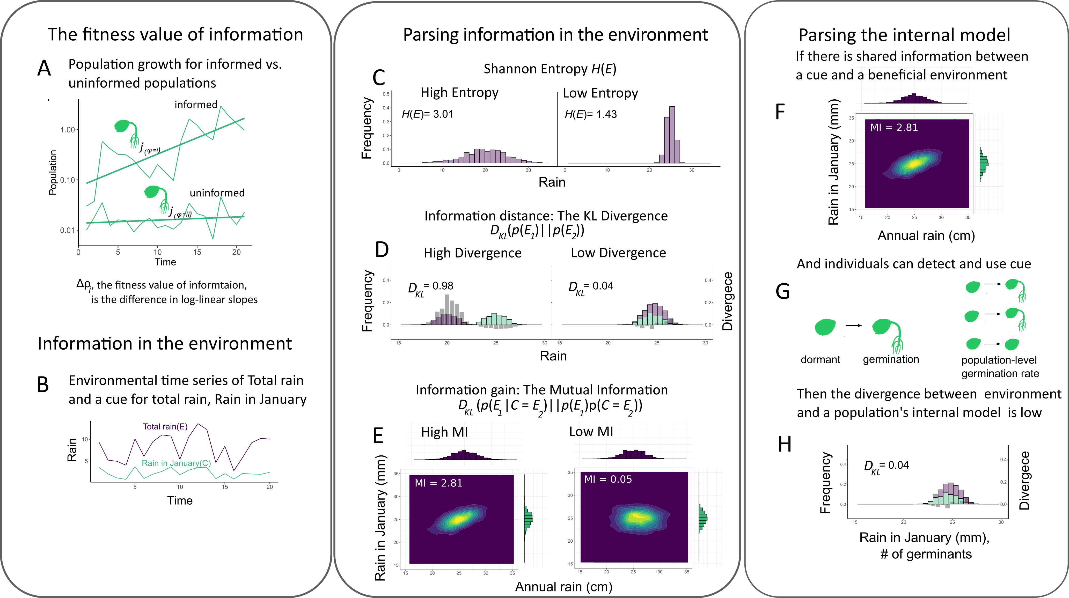
Figure 1. Conceptual layout of the fitness value of information (FVOI): see Box 1 for more details. (A) Populations recover from low density more quickly when information is present and they have an internal model of the frequency of favorable environments. The FVOI (Δ𝜌_{i}) is measured as the difference between informed and uninformed population (log) growth rates. (B) Patterns of environmental variation may serve as a cue for favorable environments, as when the amount of early-season precipitation (e.g. in January) signals the total amount of rain that will fall during the growing season. (C-E) The FVOI framework parses the information in the environment using information- theoretic metrics, using frequency distributions of environmental patterns. (C) The Shannon Entropy measures the “surprisal” of a single variable ( p(E₁)*log( p(E1) ). (D) The Kullback-Leibler (KL) divergence provides a measure of how different two variables are in their distribution (a statistical distance); bin-by-bin differences in the two variables are pictured as dark gray bars ( each bin = p(E₁)*log( p(E1)/p(E2) ) ). (E) Information gained by one variable from observing a different variable is measured by the mutual information (MI). Surface plots show the join probability distribution of two variables, whose individual (marginal) probabilities are shown along the edges. (F-H) The FVOI parses the population’s internal model using the same information theoretic metrics. (F) Populations can exploit MI between two variables by treating one variable as a cue. (G) In this example, high MI produces a reliable cue used by seeds of an annual plant species to initiate germination. (H) How efficiently a population uses this information can be measured by comparing the population-level proportion of germinants in each environment against the actual distribution of environments. Then, Δ𝜌_{i} is the difference between the MI (F) and the KL divergence of environment and internal model (H).
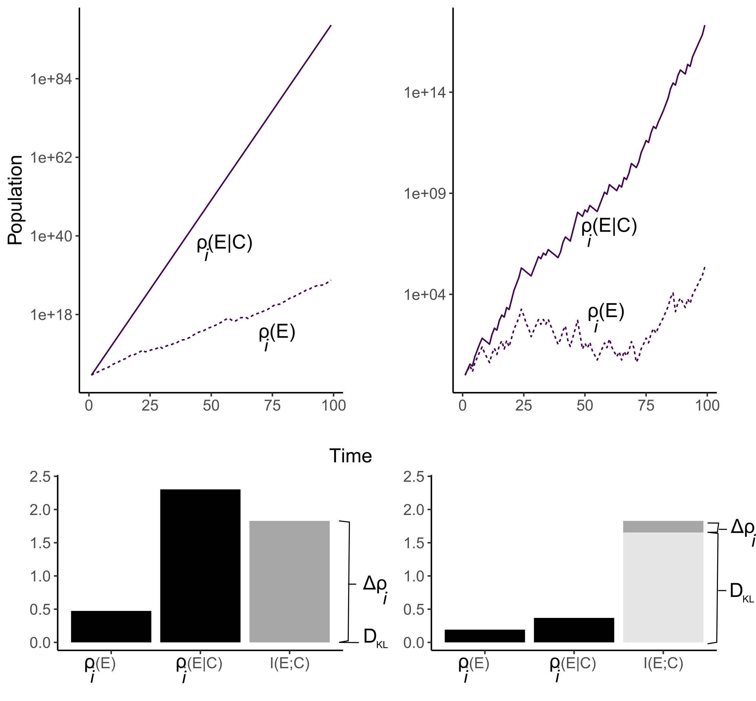
A
B
C
D
Figure 2. Population growth for two life history models: a multiplicative model (A) and a dormancy model (B) when the probability of a strategy or phenotype does not use information 𝜌_{i}(E), versus when it uses an environmental cue for information 𝜌_{i}(E|C) (see text and model details in box 1). To illustrate the relative contributions of I(E;C) and each population to the FVOI, values of the slopes 𝜌_{i}(E) and 𝜌_{i}(E|C) are shown in C and D for each model. The fitness value of information is measured by the difference between the two slopes Δ𝜌_{i}. The mutual information I(E;C) between the environment and the cue defines the maximum potential contribution of a cue to fitness, while the KL Divergence (D_{KL}) quantifies the extent to which a population fails to benefit from an informative cue; the stacked bars in C and D illustrate that the FVOI is the difference between I(E;C) and D_{KL}. See the Supporting Information for simulation details.

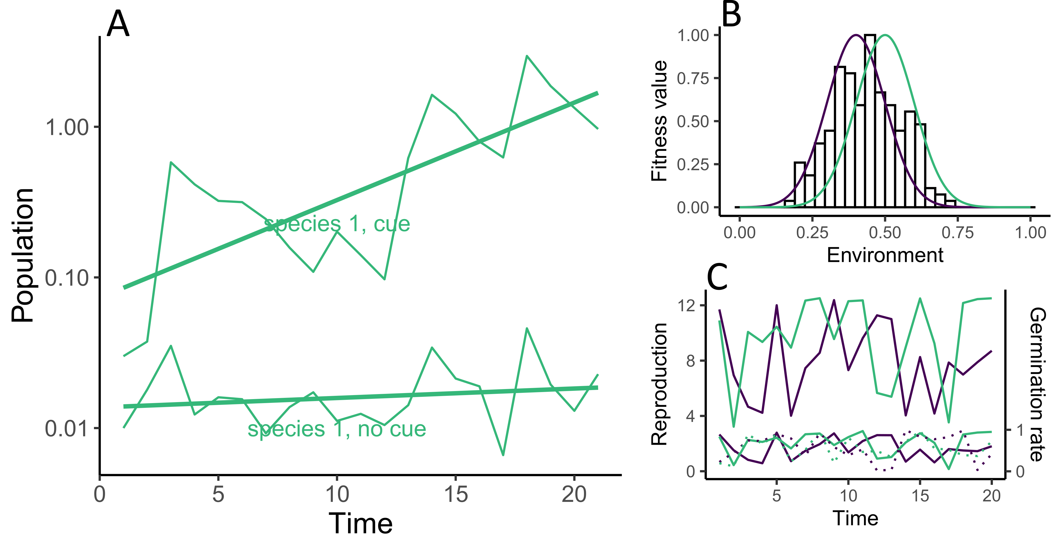Figure 3. The dynamics of the lottery model (A) for a population of species 1 (shown in green) in the presence of a competitor (not pictured in A, in purple) with and without the ability to detect an environmental cue that helps it predict favorable environmental conditions for germination (see Box 2 for model description). (B) The environment is simulated by taking draws from a normal distribution to set the conditions for each time step, without autocorrelation (μ = 0.5 and σ =0.1, B). Each species (green and purple lines) has a different optimum environment modeled as Gaussian curves so that reproductive fitness decays with the distance of an environmental state from the optimum. (C) The varying environmental state, reproduction, and germination rates are simulated as a time series. When germiation is informed ( because 𝜌_{i}(E|C) is high) then germination rates match closely to the reproduction rates in that year, as seen in the solid germination lines. When germination is not informed then there is no correlation between germination rates and reproduction; this is seen by comparing the dotted germination lines to the reproduction rates. See the Supporting Information for simulation code.

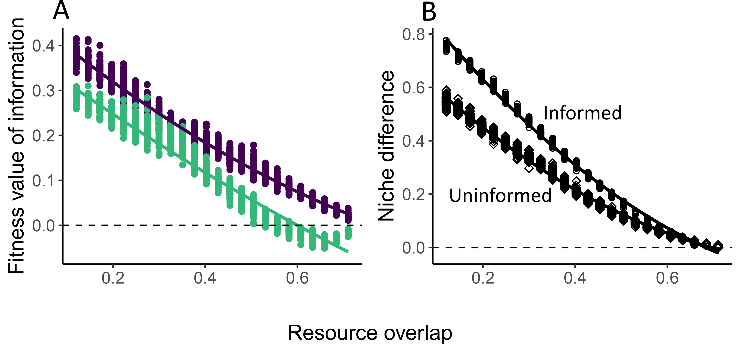
Figure 4. The change in the fitness value of information for two species (one green, one purple) competing for fluctuating resources. Competition increases with more resource overlap because species will reproduce more often under similar conditions and limit the growth of the other. (A) The fitness value of information Δ𝜌_{i} for each species decreases when competition for resources increases. (B) The niche difference between the two species when both species use information, or when both species are uninformed (i.e. 𝜌_{i}(E|C) and 𝜌_{i}(E) ) as labelled. A niche difference of 1 corresponds with 100% differentiation.

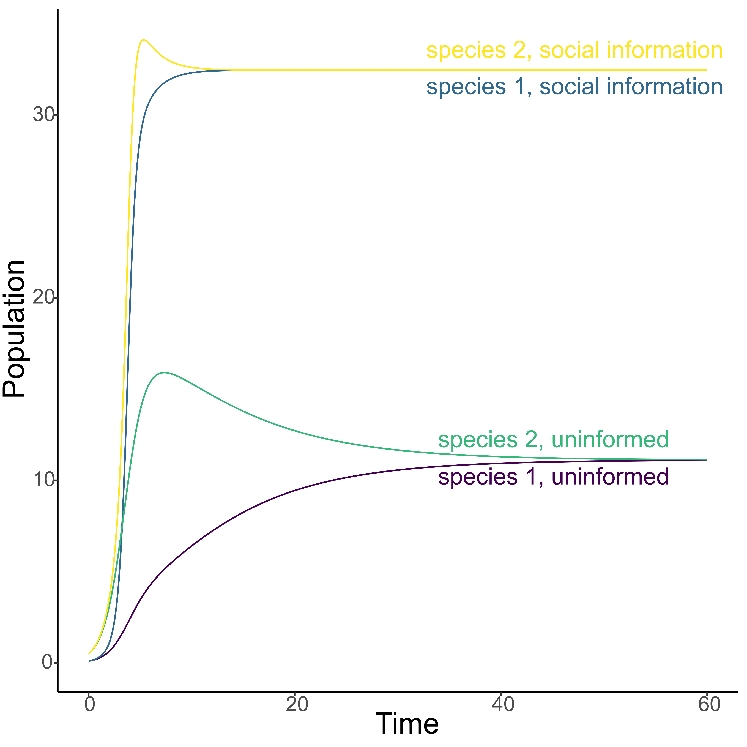

Figure 5. The population dynamics of the competition model with social information, with (upper lines) and without (lower lines) social information.

Bibliography

Acharya, L. & Fenton, M.B. (2011). Bat attacks and moth defensive behaviour around street lights. Can. J. Zool.
Adler, P.B., HilleRisLambers, J., Kyriakidis, P.C., Guan, Q. & Levine, J.M. (2006). Climate variability has a stabilizing effect on the coexistence of prairie grasses. Proc. Natl. Acad. Sci., 103, 12793–12798.
Adler, P.B., HilleRisLambers, J. & Levine, J.M. (2007). A niche for neutrality. Ecol. Lett., 10, 95–104.
Alexander, J.M. & Levine, J.M. (2019). Earlier phenology of a nonnative plant increases impacts on native competitors. Proc. Natl. Acad. Sci., 116, 6199–6204.
Angert, A.L., Huxman, T.E., Chesson, P. & Venable, D.L. (2009). Functional tradeoffs determine species coexistence via the storage effect. Proc. Natl. Acad. Sci., 106, 11641–11645.
Aplin, L.M., Farine, D.R., Morand-Ferron, J., Cockburn, A., Thornton, A. & Sheldon, B.C. (2015). Experimentally induced innovations lead to persistent culture via conformity in wild birds. Nature, 518, 538–541.
Baldwin, I.T., Halitschke, R., Paschold, A., Von Dahl, C.C. & Preston, C.A. (2006). Volatile signaling in plant-plant interactions:" talking trees" in the genomics era. science, 311, 812–815.
Barabás, G., D’Andrea, R. & Stump, S.M. (2018). Chesson’s coexistence theory. Ecol. Monogr., 88, 277–303.
Barber, J.R., Crooks, K.R. & Fristrup, K.M. (2010). The costs of chronic noise exposure for terrestrial organisms. Trends Ecol. Evol., 25, 180–189.
Barbraud, C. & Weimerskirch, H. (2003). Climate and density shape population dynamics of a marine top predator. Proc. R. Soc. Lond. B Biol. Sci., 270, 2111–2116.
Barth, F.G. & Schmid, A. (2013). Ecology of sensing. Springer Science & Business Media.
Barton, B.T., Hodge, M.E., Speights, C.J., Autrey, A.M., Lashley, M.A. & Klink, V.P. (2018). Testing the AC/DC hypothesis: Rock and roll is noise pollution and weakens a trophic cascade. Ecol. Evol., 8, 7649–7656.
Bernhardt, J.R., O’Connor, M.I., Sunday, J.M. & Gonzalez, A. (2020). Life in fluctuating environments. Philos. Trans. R. Soc. B, 375, 20190454.
Berryman, A.A., Dennis, B., Raffa, K.F. & Stenseth, N.C. (1985). Evolution of optimal group attack, with particular reference to bark beetles (Coleoptera: Scolytidae). Ecology, 66, 898–903.
Bever, J.D. & Simms, E.L. (2000). Evolution of nitrogen fixation in spatially structured populations of Rhizobium. Heredity, 85, 366–372.
Boeing, W.J. & Ramcharan, C.W. (2010). Inducible defences are a stabilizing factor for predator and prey populations: a field experiment. Freshw. Biol., 55, 2332–2338.
Bolker, B.M., Pacala, S.W. & Neuhauser, C. (2003). Spatial dynamics in model plant communities: What do we really know? Am. Nat., 162, 135–148.
Bronson, F.H. (2009). Climate change and seasonal reproduction in mammals. Philos. Trans. R. Soc. B Biol. Sci., 364, 3331–3340.
Bruce, T.J., Matthes, M.C., Napier, J.A. & Pickett, J.A. (2007). Stressful “memories” of plants: evidence and possible mechanisms. Plant Sci., 173, 603–608.
Brumm, H., Voss, K., Köllmer, I. & Todt, D. (2004). Acoustic communication in noise: regulation of call characteristics in a New World monkey. J. Exp. Biol., 207, 443–448.
Bullmore, E. & Sporns, O. (2012). The economy of brain network organization. Nat. Rev. Neurosci., 13, 336–349.
Cáceres, C.E. (1997). Temporal variation, dormancy, and coexistence: A field test of the storage effect. Proc. Natl. Acad. Sci. U. S. A., 94, 9171–9175.
Cai, Y., Hossain, M.J., Hériché, J.-K., Politi, A.Z., Walther, N., Koch, B., et al. (2018). Experimental and computational framework for a dynamic protein atlas of human cell division. Nature, 561, 411–415.
Carroll, I.T., Cardinale, B.J. & Nisbet, R.M. (2011). Niche and fitness differences relate the maintenance of diversity to ecosystem function. Ecology, 92, 1157–1165.
Chesson, P. (1994). Multispecies Competition in Variable Environments. Theor. Popul. Biol., 45, 227–276.
Chesson, P.L. & Warner, R.R. (1981). Environmental variability promotes coexistence in lottery competitive systems. Am. Nat., 117, 923.
Childs, D.Z., Metcalf, C.J.E. & Rees, M. (2010). Evolutionary bet-hedging in the real world: empirical evidence and challenges revealed by plants. Proc. R. Soc. B Biol. Sci., 277, 3055–3064.
Chivers, D.P. & Smith, R.J.F. (1998). Chemical alarm signalling in aquatic predator-prey systems: a review and prospectus. Ecoscience, 5, 338–352.
Clauss, M.J. & Venable, D.L. (2000). Seed Germination in Desert Annuals: An Empirical Test of Adaptive Bet Hedging. Am. Nat., 155, 168–186.
Cohen, D. (1966). Optimizing reproduction in a randomly varying environment. J. Theor. Biol., 12, 119–129.
Commander, L.E., Golos, P.J., Miller, B.P. & Merritt, D.J. (2017). Seed germination traits of desert perennials. Plant Ecol., 218, 1077–1091.
Costerton, J.W., Lewandowski, Z., Caldwell, D.E., Korber, D.R. & Lappin-Scott, H.M. (1995). Microbial biofilms. Annu. Rev. Microbiol., 49, 711–745.
Cotton, P.A. (2003). Avian migration phenology and global climate change. Proc. Natl. Acad. Sci., 100, 12219–12222.
Cover, T.M. & Thomas, J.A. (2006). Elements of Information Theory. John Wiley & Sons.
Crespi, B.J. (2001). The evolution of social behavior in microorganisms. Trends Ecol. Evol., 16, 178–183.
Crisp, P.A., Ganguly, D., Eichten, S.R., Borevitz, J.O. & Pogson, B.J. (2016). Reconsidering plant memory: Intersections between stress recovery, RNA turnover, and epigenetics. Sci. Adv., 2, e1501340.
Crone, E.E., Miller, E. & Sala, A. (2009). How do plants know when other plants are flowering? Resource depletion, pollen limitation and mast-seeding in a perennial wildflower. Ecol. Lett., 12, 1119–1126.
Danchin, E., Giraldeau, L.-A., Valone, T.J. & Wagner, R.H. (2004). Public information: from nosy neighbors to cultural evolution. Science, 305, 487–491.
Dangles, O., Irschick, <? break?> Duncan, Chittka, <? break?> Lars & Casas, <? break?> Jérôme. (2009). Variability in sensory ecology: expanding the bridge between physiology and evolutionary biology. Q. Rev. Biol., 84, 51–74.
De Moraes, C.M., Lewis, W.J., Paré, P.W., Alborn, H.T. & Tumlinson, J.H. (1998). Herbivore-infested plants selectively attract parasitoids. Nature, 393, 570–573.
Devaux, C. & Lande, R. (2009). Displacement of flowering phenologies among plant species by competition for generalist pollinators. J. Evol. Biol., 22, 1460–1470.
Donaldson-Matasci, M.C., Bergstrom, C.T. & Lachmann, M. (2010). The fitness value of information. Oikos, 119, 219–230.
Donaldson-Matasci, M.C., Lachmann, M. & Bergstrom, C.T. (2008). Phenotypic diversity as an adaptation to environmental uncertainty. Evol. Ecol. Res., 10, 493–515.
Durrett, R. & Levin, S. (1997). Allelopathy in spatially distributed populations. J. Theor. Biol., 185, 165–171.
Ellner, S. (1987). Alternate plant life history strategies and coexistence in randomly varying environments. Vegetatio, 69, 199–208.
Ellner, S.P. (1997). You bet your life: life-history strategies in fluctuating environments. Case Stud. Math. Model. Ecol. Physiol. Cell Biol., 3–24.
Ellner, S.P., Snyder, R.E. & Adler, P.B. (2016). How to quantify the temporal storage effect using simulations instead of math. Ecol. Lett.
Fabina, N.S., Abbott, K.C. & Gilman, R.T. (2010). Sensitivity of plant–pollinator–herbivore communities to changes in phenology. Ecol. Model., 221, 453–458.
Firebaugh, A. & Haynes, K.J. (2019). Light pollution may create demographic traps for nocturnal insects. Basic Appl. Ecol., 34, 118–125.
Frank, S.A. (2012). Natural selection. V. How to read the fundamental equations of evolutionary change in terms of information theory. J. Evol. Biol., 25, 2377–2396.
Frank, S.A. (2016). The invariances of power law size distributions. F1000Research, 5.
Furness, A.I., Lee, K. & Reznick, D.N. (2015). Adaptation in a variable environment: Phenotypic plasticity and bet-hedging during egg diapause and hatching in an annual killifish. Evolution, 69, 1461–1475.
Gil, M.A., Baskett, M.L. & Schreiber, S.J. (2019). Social information drives ecological outcomes among competing species. Ecology, 100, e02835.
Gil, M.A., Baskett, M.L., Munch, S.B. & Hein, A.M. (2020). Fast behavioral feedbacks make ecosystems sensitive to pace and not just magnitude of anthropogenic environmental change. Proceedings of the National Academy of Sciences, 117, 25580–25589.
Gil, M.A., Emberts, Z., Jones, H. & St. Mary, C.M. (2017). Social information on fear and food drives animal grouping and fitness. The American Naturalist, 189, 227–241.
Gil, M.A., Hein, A.M., Spiegel, O., Baskett, M.L. & Sih, A. (2018). Social information links individual behavior to population and community dynamics. Trends Ecol. Evol., 33, 535–548.
Gillespie, J.H. (1974). Natural selection for within-generation variance in offspring number. Genetics, 76, 601–606.
Godoy, O. & Levine, J.M. (2014). Phenology effects on invasion success: insights from coupling field experiments to coexistence theory. Ecology, 95, 726–736.
Goldenfeld, N. & Woese, C. (2007). Biology’s next revolution. Q-Bio0702015.
Gould, J.P. (1974). Risk, stochastic preference, and the value of information. J. Econ. Theory, 8, 64–84.
Grainger, T.N., Levine, J.M. & Gilbert, B. (2019). The Invasion Criterion: A Common Currency for Ecological Research. Trends Ecol. Evol., 34, 925–935.
Hairston Jr, N.G. & Kearns, C.M. (1995). The interaction of photoperiod and temperature in diapause timing: a copepod example. Biol. Bull., 189, 42–48.
Hairston, N.G. & Dillon, T.A. (1990). Fluctuating selection and response in a population of freshwater copepods. Evolution, 44, 1796–1805.
Haldane, J.B.S. & Jayakar, S.D. (1963). Polymorphism due to selection of varying direction. J. Genet., 58, 237–242.
Hammill, E., Rogers, A. & Beckerman, A.P. (2008). Costs, benefits and the evolution of inducible defences: a case study with Daphnia pulex. J. Evol. Biol., 21, 705–715.
Hart, S.P., Usinowicz, J. & Levine, J.M. (2017). The spatial scales of species coexistence. Nat. Ecol. Evol., 1, 1066.
Harvell, C.D. (1992). Inducible defenses and allocation shifts in a marine bryozoan. Ecology, 73, 1567–1576.
Hegland, S.J., Nielsen, A., Lázaro, A., Bjerknes, A.-L. & Totland, Ø. (2009). How does climate warming affect plant-pollinator interactions? Ecol. Lett., 12, 184–195.
Hein, A.M. & Martin, B.T. (2020). Information limitation and the dynamics of coupled ecological systems. Nature Ecology & Evolution, 4, 82–90.
Horton, K.G., La Sorte, F.A., Sheldon, D., Lin, T.-Y., Winner, K., Bernstein, G., et al. (2020). Phenology of nocturnal avian migration has shifted at the continental scale. Nat. Clim. Change, 10, 63–68.
Horváth, G., Kriska, G., Malik, P. & Robertson, B. (2009). Polarized light pollution: a new kind of ecological photopollution. Front. Ecol. Environ., 7, 317–325.
Huffaker, C. (1958). Experimental studies on predation: dispersion factors and predator-prey oscillations. Hilgardia, 27, 343–383.
Inouye, D.W., Barr, B., Armitage, K.B. & Inouye, B.D. (2000). Climate change is affecting altitudinal migrants and hibernating species. Proc. Natl. Acad. Sci., 97, 1630–1633.
Jackson, S.T., Betancourt, J.L., Booth, R.K. & Gray, S.T. (2009). Ecology and the ratchet of events: climate variability, niche dimensions, and species distributions. Proc. Natl. Acad. Sci., pnas-0901644106.
Jenni, L. & Kéry, M. (2003). Timing of autumn bird migration under climate change: advances in long–distance migrants, delays in short–distance migrants. Proc. R. Soc. Lond. B Biol. Sci., 270, 1467–1471.
Jones, S.E. & Lennon, J.T. (2010). Dormancy contributes to the maintenance of microbial diversity. Proc. Natl. Acad. Sci.
Jose M. Facelli, Peter Chesson & Nicola Barnes. (2008). DIFFERENCES IN SEED BIOLOGY OF ANNUAL PLANTS IN ARID LANDS: A KEY INGREDIENT OF THE STORAGE EFFECT. Available at: http://www.esajournals.org/doi/abs/10.1890/05-0304. Last accessed 8 July 2009.
Kane, A. & Kendall, C.J. (2017). Understanding how mammalian scavengers use information from avian scavengers: cue from above. J. Anim. Ecol., 86, 837–846.
Keller, L. & Surette, M.G. (2006). Communication in bacteria: an ecological and evolutionary perspective. Nat. Rev. Microbiol., 4, 249–258.
Kelly, J.L. (1956). A new interpretation of information rate. Bell Syst. Tech. J., 35, 917–926.
Kempes, C.P., Wolpert, D., Cohen, Z. & Pérez-Mercader, J. (2017). The thermodynamic efficiency of computations made in cells across the range of life. Phil Trans R Soc A, 375, 20160343.
Koch, K. (2004). Sucrose metabolism: regulatory mechanisms and pivotal roles in sugar sensing and plant development. Curr. Opin. Plant Biol., 7, 235–246.
Koštál, V., Štětina, T., Poupardin, R., Korbelová, J. & Bruce, A.W. (2017). Conceptual framework of the eco-physiological phases of insect diapause development justified by transcriptomic profiling. Proc. Natl. Acad. Sci., 114, 8532–8537.
Kussell, E. & Leibler, S. (2005). Phenotypic diversity, population growth, and information in fluctuating environments. Science, 309, 2075–2078.
Laughlin, S.B., van Steveninck, R.R. de R. & Anderson, J.C. (1998). The metabolic cost of neural information. Nat. Neurosci., 1, 36–41.
Leff, H.S. & Rex, A.F. (2014). Maxwell’s demon: entropy, information, computing. Princeton University Press.
Letten, A.D., Dhami, M.K., Ke, P.-J. & Fukami, T. (2018). Species coexistence through simultaneous fluctuation-dependent mechanisms. Proc. Natl. Acad. Sci., 201801846.
Levin, S.A. (1992). The problem of pattern and scale in ecology: the Robert H. MacArthur award lecture. Ecology, 73, 1943–1967.
Longcore, T. & Rich, C. (2004). Ecological light pollution. Front. Ecol. Environ., 2, 191–198.
Magrath, R.D., Haff, T.M., Fallow, P.M. & Radford, A.N. (2015). Eavesdropping on heterospecific alarm calls: from mechanisms to consequences. Biol. Rev., 90, 560–586.
Marleau, J.N., Peller, T., Guichard, F. & Gonzalez, A. (2020). Converting Ecological Currencies: Energy, Material, and Information Flows. Trends Ecol. Evol.
McMahon, T.A., Rohr, J.R. & Bernal, X.E. (2017). Light and noise pollution interact to disrupt interspecific interactions. Ecology, 98, 1290–1299.
McNamara, J.M., Barta, Z., Klaassen, M. & Bauer, S. (2011). Cues and the optimal timing of activities under environmental changes. Ecol. Lett., 14, 1183–1190.
Miehls, A.L., McAdam, A.G., Bourdeau, P.E. & Peacor, S.D. (2013). Plastic response to a proxy cue of predation risk when direct cues are unreliable. Ecology, 94, 2237–2248.
Moeller, D.A. (2004). Facilitative interactions among plants via shared pollinators. Ecology, 85, 3289–3301.
Montgomery, R.A., Rice, K.E., Stefanski, A., Rich, R.L. & Reich, P.B. (2020). Phenological responses of temperate and boreal trees to warming depend on ambient spring temperatures, leaf habit, and geographic range. Proc. Natl. Acad. Sci., 117, 10397–10405.
Nelson, M.E. & MacIver, M.A. (2006). Sensory acquisition in active sensing systems. J. Comp. Physiol. A, 192, 573–586.
O’Connor, M.I., Pennell, M.W., Altermatt, F., Matthews, B., Melián, C.J. & Gonzalez, A. (2019). Principles of Ecology Revisited: Integrating Information and Ecological Theories for a More Unified Science. Front. Ecol. Evol., 7.
Pake, C.E. & Venable, D.L. (1995). Is Coexistence of Sonoran Desert Annuals Mediated by Temporal Variability Reproductive Success. Ecology, 76, 246–261.
Parrondo, J.M., Horowitz, J.M. & Sagawa, T. (2015). Thermodynamics of information. Nat. Phys., 11, 131–139.
Patricelli, G.L. & Blickley, J.L. (2006). Avian communication in urban noise: causes and consequences of vocal adjustment. The Auk, 123, 639–649.
Peacor, S.D. & Werner, E.E. (2004). How dependent are species-pair interaction strengths on other species in the food web? Ecology, 85, 2754–2763.
Pennekamp, F., Iles, A.C., Garland, J., Brennan, G., Brose, U., Gaedke, U., et al. (2019). The intrinsic predictability of ecological time series and its potential to guide forecasting. Ecol. Monogr., 89, e01359.
Philippi, T. & Seger, J. (1989). Hedging one’s evolutionary bets, revisited. Trends Ecol. Evol., 4, 41–44.
Post, E. & Forchhammer, M.C. (2008). Climate change reduces reproductive success of an Arctic herbivore through trophic mismatch. Philos. Trans. R. Soc. B Biol. Sci., 363, 2367–2373.
Relyea, R.A. (2003). Predators come and predators go: the reversibility of predator-induced traits. Ecology, 84, 1840–1848.
Rivoire, O. & Leibler, S. (2011). The value of information for populations in varying environments. J. Stat. Phys., 142, 1124–1166.
Robertson, B.A., Rehage, J.S. & Sih, A. (2013). Ecological novelty and the emergence of evolutionary traps. Trends Ecol. Evol., 28, 552–560.
Salmon, M., Tolbert, M.G., Painter, D.P., Goff, M. & Reiners, R. (1995). Behavior of Loggerhead Sea Turtles on an Urban Beach. II. Hatchling Orientation. J. Herpetol., 29, 568–576.
Schauber, E.M., Kelly, D., Turchin, P., Simon, C., Lee, W.G., Allen, R.B., et al. (2002). Masting by Eighteen New Zealand Plant Species: The Role of Temperature as a Synchronizing Cue. Ecology, 83, 1214–1225.
Schlaepfer, M.A., Runge, M.C. & Sherman, P.W. (2002). Ecological and evolutionary traps. Trends Ecol. Evol., 17, 474–480.
Schmidt, K.A., Johansson, J. & Betts, M.G. (2015). Information-mediated Allee effects in breeding habitat selection. Am. Nat., 186, E162–E171.
Sears, A.L. & Chesson, P. (2007). New methods for quantifying the spatial storage effect: an illustration with desert annuals. Ecology, 88, 2240–2247.
Secor, D.H. (2007). The year-class phenomenon and the storage effect in marine fishes. J. Sea Res., 57, 91–103.
Shoemaker, L.G. & Melbourne, B.A. (2016). Linking metacommunity paradigms to spatial coexistence mechanisms. Ecology, 97, 2436–2446.
Smith, J.M. (1999). The idea of information in biology. Q. Rev. Biol., 74, 395–400.
Snyder, R.E. (2006). Multiple risk reduction mechanisms: can dormancy substitute for dispersal? Ecol. Lett., 9, 1106–1114.
Stephens, D.W. (1989). Variance and the value of information. Am. Nat., 134, 128–140.
Stephens, P.A., Frey-roos, F., Arnold, W. & Sutherland, W.J. (2002). Model complexity and population predictions. The alpine marmot as a case study. J. Anim. Ecol., 71, 343–361.
Strauss, S.Y. (1997). Floral Characters Link Herbivores, Pollinators, and Plant Fitness. Ecology, 78, 1640–1645.
Stumpf, M.P., Laidlaw, Z. & Jansen, V.A. (2002). Herpes viruses hedge their bets. Proc. Natl. Acad. Sci., 99, 15234–15237.
Sultan, S.E. (2000). Phenotypic plasticity for plant development, function and life history. Trends Plant Sci., 5, 537–542.
Suttle, K.B., Thomsen, M.A. & Power, M.E. (2007). Species interactions reverse grassland responses to changing climate. science, 315, 640–642.
Ten Brink, H., Gremer, J.R. & Kokko, H. (2020). Optimal germination timing in unpredictable environments: the importance of dormancy for both among-and within-season variation. Ecol. Lett., 23, 620–630.
Thackeray, S.J., Henrys, P.A., Hemming, D., Bell, J.R., Botham, M.S., Burthe, S., et al. (2016). Phenological sensitivity to climate across taxa and trophic levels. Nature, 535, 241–245.
Tielbörger, K., Petru\uu, M. & Lampei, C. (2012). Bet-hedging germination in annual plants: a sound empirical test of the theoretical foundations. Oikos, 121, 1860–1868.
Tkačik, G. & Bialek, W. (2016). Information processing in living systems. Annu. Rev. Condens. Matter Phys., 7, 89–117.
Turelli, M. (1978). Does environmental variability limit niche overlap? Proc. Natl. Acad. Sci., 75, 5085–5089.
Tyson, J.J., Csikasz-Nagy, A. & Novak, B. (2002). The dynamics of cell cycle regulation. Bioessays, 24, 1095–1109.
Tyson, R. & Lutscher, F. (2016). Seasonally varying predation behavior and climate shifts are predicted to affect predator-prey cycles. Am. Nat., 188, 539–553.
Usinowicz, J. (2015). Limited Dispersal Drives Clustering and Reduces Coexistence by the Storage Effect. Am. Nat., 186, 634–648.
Usinowicz, J., Chang-Yang, C.-H., Chen, Y.-Y., Clark, J.S., Fletcher, C., Garwood, N.C., et al. (2017). Temporal coexistence mechanisms contribute to the latitudinal gradient in forest diversity. Nature, 550, 105–108.
Usinowicz, J., Wright, S.J. & Ives, A.R. (2012). Coexistence in tropical forests through asynchronous variation in annual seed production. Ecology, 93, 2073–2084.
Venable, D.L. & Lawlor, L. (1980). Delayed germination and dispersal in desert annuals: escape in space and time. Oecologia, 46, 272–282.
Werner, E.E. & Peacor, S.D. (2003). A review of trait-mediated indirect interactions in ecological communities. Ecology, 84, 1083–1100.
Williams, P., Camara, M., Hardman, A., Swift, S., Milton, D., Hope, V.J., et al. (2000). Quorum sensing and the population-dependent control of virulence. Philos. Trans. R. Soc. Lond. B. Biol. Sci., 355, 667–680.
Wilsterman, K., Ballinger, M.A. & Williams, C.M. (2021). A unifying, eco-physiological framework for animal dormancy. Funct. Ecol., 35, 11–31.
Woods, H.A. & Wilson, J.K. (2013). An information hypothesis for the evolution of homeostasis. Trends Ecol. Evol., 28, 283–289.

